

23rd January, 2020

Dear Sir

**ID CARD PRINT PROPOSAL**

We are pleased to introduce our company to you.

Since our establishment we have provided for our clients the following services

* **Website Development**
* **Software Development**
* **Corporate Graphics**
* **Staff I.T. Training**
* **Bulk SMS**
* **ID Cards**

We shall be delighted in extending our ID card printing service to your company.

Please find attached to this letter, features of our proposed ID card printing service for your consideration.

We look forward to a long lasting relationship with your company.

Thank you for your cooperation.

Yours faithfully,

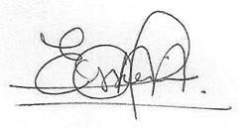

**PaaFranz E. Arthur**

**(General Manager)**

**CLIENTS (PRINT OF STAFF IDS)**

Below are some of our major clients we have printed staff ID Cards for

* Glo Mobile Ghana
* Reliance Personnel Services
* Huawei Technologies (GH) S.A. Ltd.
* Royal Senchi Hotel & Resort
* Ghallywood Film Academy
* UBI Micro-credit Services
* Advanced Cardiovascular Life Support
* Prudential Life Insurance Ghana
* Key Architecture
* Baldwin University College
* Apostle J.K. Okpoti Theological Institution
* Poly Tanks GH
* Mohinani GH
* Somotex/Somoco
* Kokrokoo Foundation

Plus some schools and other organizations

**TURN AROUND TIME**

Our turnaround time depends on the quantity to be printed. However we are able to print and deliver 100 cards in two (2) working days

**PROCESS**

- Client must submit a template artwork for the ID Card, In the event client has no artwork for our graphic design team will create an artwork at a fee of GHC150

- Pictures to be used by staff for IDs would sent via our dedicated whatsapp line 0501282006 in the format below.

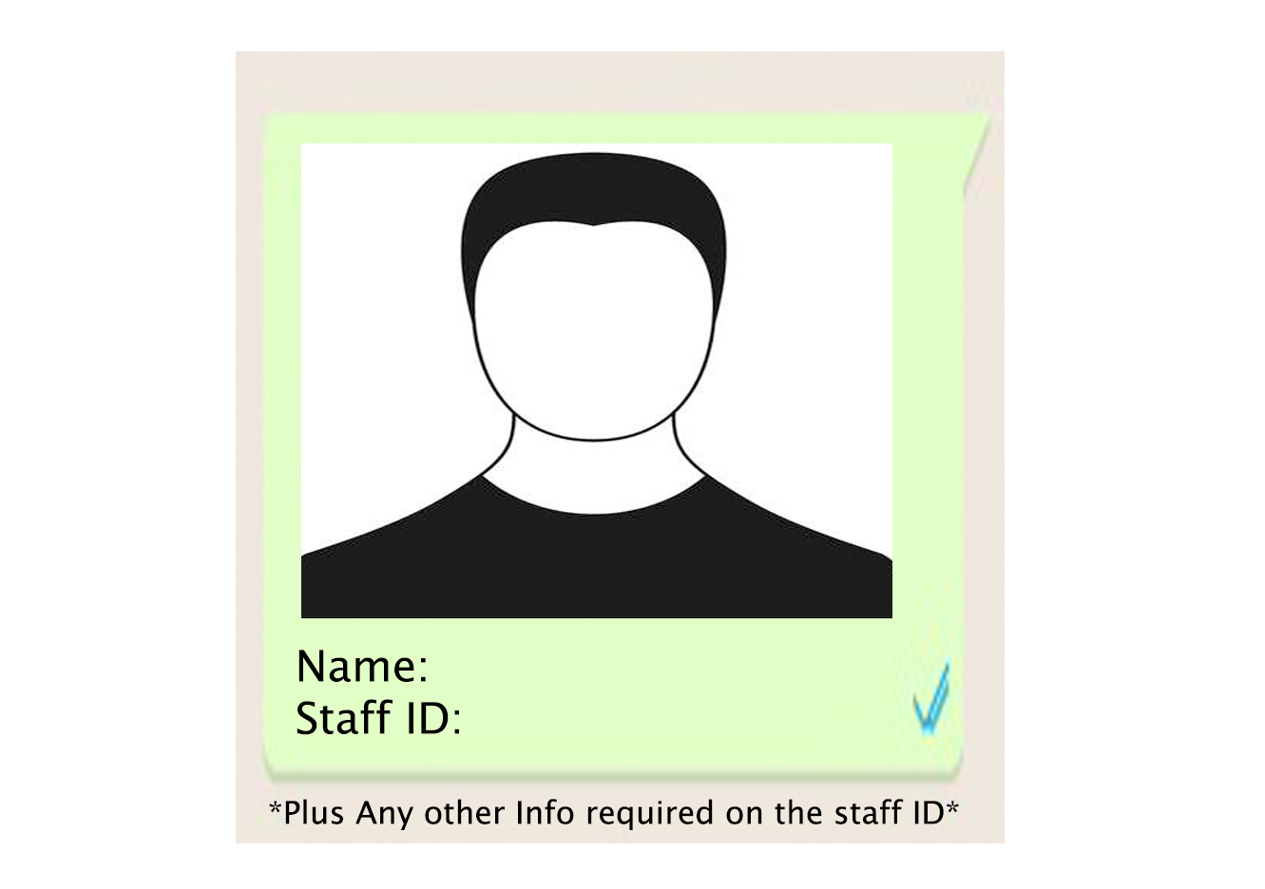

-A soft copy of one Staff ID Card with Staff details will be send to client for approval before printing commences.

- Printed Staff ID Cards would be delivered to Clients Head Office.

**PAYMENT TERMS**

**NB: PRICES QUOTED ABOVE ARE VAT EXCLUSIVE**

* 60% Down Payment Before Commencement
* 40% Payment after virtual tour is completed and delivered

|  |  |  |
| --- | --- | --- |
| **BANK** | **UBA** | **FIDELITY** |
| Branch | Madina | Adenta |
| A/C name | Essien Arthur Computing Limited | Essien Arthur Computing Limited |
| A/C number | 01005492601503 | 1050026958915 |